AUDITION PACKET

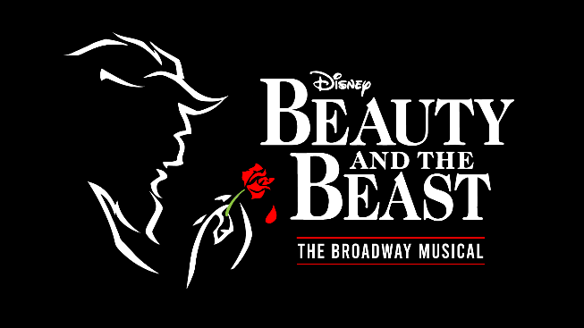

Audition Dates:
Saturday, February 11, at 2:30pm
Sunday, February 12, at 2:30pm

Potential Mandatory Callbacks:
Friday, February 17, at 6:00pm

Show Dates:
June 7, 8, & 9, 7p.m
June 10, 1pm & 7p.m
June 11, 3p.m

Production Team:

*Director/Choreographer
Kendrix Singletary

*Stage/Show Manager
Jonathan Brewington
Jonathan@CarolinaCivicCenter.com

*Music Director
James Clark

Rehearsals: (tentatively) Weekday Evenings 6-9pm & Weekends Mornings 10am-1pm at the
Carolina Civic Center Historic Theater beginning March, 2023

IN THIS PACKET:

*Character Breakdown
*Audition Form
*Commitment Calendar
*Risk and Waiver of Liability

((Keep For Your Records))
CHARACTER BREAKDOWN:
Belle
A young woman with an independent spirit and a love of reading who exudes natural beauty

Beast
The cursed Prince and master of the castle

Maurice
Belle’s slightly addled genius inventor father

Gaston
A rude, narcissistic hunter who assumes the world belongs to him

Lefou
Gaston’s fawning friend, not too bright.

Les Filles De La Ville (3)
A group of Gaston’s fanatical female followers who energetically pursue him in the hopes of winning

Lumiere
A charming French valet who fancies himself a ladies man; becomes a candelabra

Cogsworth
An officious, excitable, English major-domo; becomes a mantle clock

Mrs. Potts
A sweet, kind-hearted head of the kitchen staff and mother to Chip; becomes a teapot

Chip
Mrs. Potts’s hopeful youngster; becomes a teacup

Madame De La Grande Bouche
A grand, larger-than-life opera singer; becomes a wardrobe

Babette
A flirtatious maid; becomes a feather duster.

Monsieur D'arque
Proprietor of the local insane asylum

Villagers
Includes Shepherd, Marie, Tavern Master, Laundry Lady, Baker, Milkmaid, Flower Seller, Sausage Curl Lady, Candle Maker, Hat Seller, Bookseller, Cronies

Castle Staff
Becomes various objects, including a Gargoyle, Flatware, and Napkins

Narrator
Begins the tale of the young Prince who became a beast

Young Prince
A spoiled, orphaned young man

Old Beggar Woman
An enchantress in disguise

Wolves
((Keep For Your Records))

AUDITION FORM:

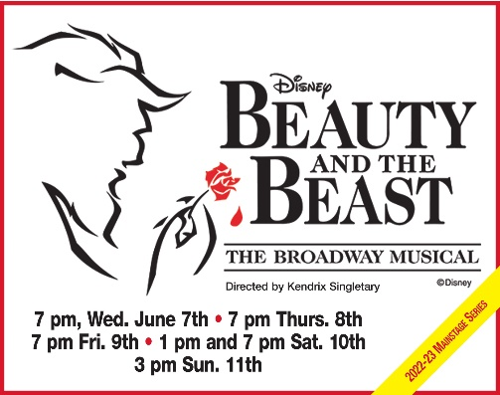

If the actor/actress auditioning is a minor, please list parent/guardian: name, email, phone number

PRINT CLEARLY!
Name
Age
Email
Phone #
Address
Vocal Range/Voice Part
(if known)
Desired Role(s)
Are you willing to accept a different role?
Theater/Show Experience | Please list all recent show experience
List ALL days you’re available to rehearse during a 7-day week

(office use ONLY)
Notes: Callback? _____

((Return to Audition))
COMMITMENT CALENDAR: Beauty And The Beast!

Name: ________________________________________

FILL IN ANY ABSOLUTE CONFLICTS KNOWN on the week and weekend dates below and return in order to audition. CHECK THIS OVER CAREFULLY; additions or changes may not be accommodated after the rehearsal schedule is set. This commitment calendar and your availability will play a role when casting this performance.

March 2023

Sun | Mon | Tue | Wed | Thu | Fri | Sat
 |  |  | 1 | 2 | 3 | 4
5 | 6 | 7 | 8 | 9 | 10 | 11
12 | 13 | 14 | 15 | 16 | 17 | 18
 |  |  |  |  | X | X
19 | 20 | 21 | 22 | 23 | 24 | 25
26 | 27 | 28 | 29 | 30 | 31

April 2023

Sun | Mon | Tue | Wed | Thu | Fri | Sat
 |  |  |  |  |  | 1
 |  |  |  |  |  | X
2 | 3 | 4 | 5 | 6 | 7 | 8
9 | 10 | 11 | 12 | 13 | 14 | 15
Easter
16 | 17 | 18 | 19 | 20 | 21 | 22
23 | 24 | 25 | 26 | 27 | 28 | 29
30

Continued on next page… ((Return to Audition))

COMMITMENT CALENDAR: Beauty And The Beast!

Name: ________________________________________

May 2023

Sun | Mon | Tue | Wed | Thu | Fri | Sat
 | 1 | 2 | 3 | 4 | 5 | 6
7 | 8 | 9 | 10 | 11 | 12 | 13
14 | 15 | 16 | 17 | 18 | 19 | 20
21 | 22 | 23 | 24 | 25 | 26 | 27
28 | 29 | 30 | 31
Mandatory
Rehearsal

June 2023

Sun | Mon | Tue | Wed | Thu | Fri | Sat
 |  |  |  | 1 | 2 | 3
 |  |  |  | Mandatory  Rehearsal | Mandatory  Rehearsal | Mandatory  Rehearsal
4 | 5 | 6 | 7 | 8 | 9 | 10
Mandatory  Rehearsal | Mandatory  Rehearsal | Mandatory  Rehearsal | Show  Day | Show  Day | Show  Day | Show  Day
11
Show
Day

Describe any other work or extra-curricular CONFLICTS that you have with rehearsals or performances, please. Be specific:

((Return to Audition))

Assumption of the Risk and Waiver of Liability Relating to
Coronavirus/COVID-19

The novel coronavirus, COVID-19, has been declared a worldwide pandemic by the World Health Organization. COVID-19 is extremely contagious and is believed to spread mainly from person-to-person contact. As a result, federal, state, and local governments and federal and state health agencies recommend masks or other face coverings, and social distancing and have, in many locations, prohibited the congregation of groups of people.
The Carolina Civic Center Historic Theater has put in place preventative measures to reduce the spread of COVID-19; however, the Carolina Civic Center cannot guarantee that you, your family, or your participating child will not become infected with COVID-19. Further, attending the Carolina Civic Center could increase your risk, your family's risk, and your child's risk of contracting COVID-19.

By signing this agreement, I acknowledge the contagious nature of COVID-19 and voluntarily assume the risk that my family, participating child and I may be exposed to or infected by COVID-19 by attending the Carolina Civic Center and that such exposure or infection may result in personal injury, illness, permanent disability, and death. I understand that the risk of becoming exposed to or infected by COVID-19 at the Carolina Civic Center may result from the actions, omissions, or negligence of myself and others, including, but not limited to, CCC employees, volunteers, and program participants and their families.
I voluntarily agree to assume all of the foregoing risks and accept sole responsibility for any injury to my child(ren) or myself (including, but not limited to, personal injury, disability, and death), illness, damage, loss, claim, liability, or expense, of any kind, that I, my family, or my participating child may experience or incur in connection with any attendance at the Carolina Civic Center. On my behalf, and on behalf of my child and family, I hereby release, covenant not to sue, discharge, and hold harmless the Carolina Civic Center, its employees, agents, and representatives, of and from the claims, including all liabilities, claims, actions, damages, costs or expenses of any kind arising out of or relating thereto. I understand and agree that this release includes any claims based on the actions, omissions, or negligence of the Carolina Civic Center, its employees, agents, and representatives, whether a COVID-19 infection occurs before, during, or after participation in any CCC program.

Also, I agree to inform the staff at the Carolina Civic Center immediately if my child(ren) or myself tests positive for Covid-19 or has any symptoms of Covid-19 or has a fever of 100.4. If any of the above applies, I agree to keep my child(ren) and/or myself from the theater until we are symptom free for 24 hours.

________________________________________________________________________________
Printed Name of Minor (under 18 years of age) Signature of Responsible Adult Date

((Return to Audition))

